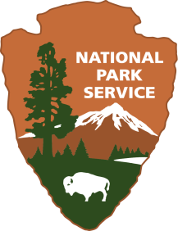**Wax Museum**

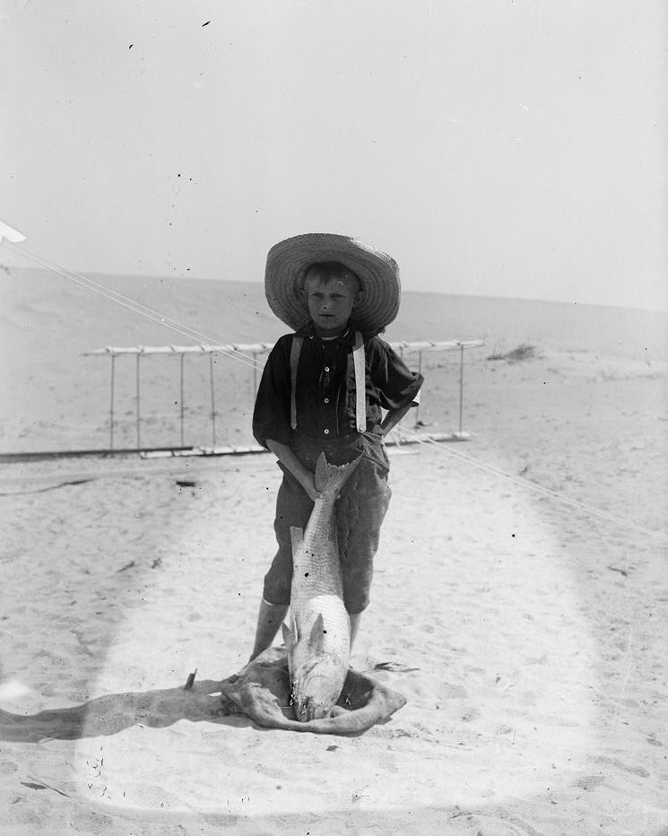**Wright Brothers National Memorial**

|  |
| --- |
|  |

**Location:** On site

**Grade:** 4th Grade

**Subject:** Arts Education – Theatre Arts

**Duration:** 30 minutes

**Key Vocabulary:** witness, wax museum, surfmen

**North Carolina State Standards:**

**4.C.2.1** Use improvisation to tell stories and express ideas

**4.CU.1.2** Create theatrical works that exemplify aspects of the culture, beliefs and history of North Carolina.

|  |
| --- |
|  |

**Materials:**

“Setting the Scene” narrative

**Site Significance:** The Wright brothers achieved the first successful powered flight at Kitty Hawk, North Carolina on December 17, 1903. There were 5 people from the community that witnessed this historical event. On the 100th anniversary of flight, the Wright brothers were memorialized with life-sized statues depicting them with their flying machine. Three years later, the 5 witnesses to this miraculous event were added to the memorial.

**Objectives:** The student will be able to

* Recreate the scene of the first successful flight with the Wright brothers and the 5 witnesses that were present
* Use improvisation to role play what that event looked like

**Essential Question:** Do we connect to a historical event better through reading about it or by experiencing it?

**Background:** This activity takes place at the site of the 7 statues in the park that depict the actual moment before the first flight. Orville Wright is the pilot and Wilbur is beside the plane. John Daniels, a surfman from the Kill Devil Hills Life-Saving station is behind the camera; 2 other surfmen were present, W.S. Dough and A.D. Etheridge; a lumberman from Manteo, W.C. Brinkley; and a young boy, Johnny Moore of Nags Head.

|  |
| --- |
|  |

**Suggested Procedure:**

**Pre-Visit:** Using some of the suggested books in the resource section of this plan, students should have general knowledge about the Wright brothers and their experiments. They should also be familiar with the job of surfmen on the Outer Banks at that time. See link under additional resources for information about surfmen. Students might possibly research the witnesses before coming to the park so they will have prior knowledge about each individual.

**On-Site:**

1. Take students to the south side of the park to view the memorial statues. Give them an opportunity to read the historical panels and explore each statue.
2. Call the group together and see what they noticed about each statue. Elicit questions about their facial expressions, clothing, why is the boy barefoot in December? Why were each of the 5 witnesses there?
3. Set the scene. Read or tell about that particular moment in time using the “Setting the Scene” narrative. Use expression to make the scene dramatic.
4. Ask students what thoughts or feelings these historical figures might be experiencing at this particular moment. How might you describe their physical and emotional feelings? After some discussion, ask if there are volunteers that might like to act out what they think may have happened next.
5. Ask if students are familiar with a Wax Museum. Wax figures are perfectly still and suddenly become animated telling about their lives. Relate this activity to that except their role will be to act out what they think each figure did as soon as the Wright Flyer got off of the ground.
6. Have volunteers take their places beside each figure and strike the same pose. Go to each figure and have them become animated with the action and words they think that figure may have used. After each one has performed individually, have them all repeat it at once, as if it actually happened. See if others might have a different version to act out. Repeat as necessary until all students that are willing have had an opportunity to perform.

**Post-Visit:**

When students return to class, they could do a short writing about what it felt like to take on the role of a historical figure.

|  |
| --- |
|  |

**Concluding Questions:**

What do you think the people that lived on the Outer Banks thought of the 2 inventors and their flying machine? Explain how you came to that conclusion.

Do you think the Wright brothers would have been successful without the help of the Outer Banks community? Explain.

**Evaluation:** Writing artifacts, discussion participation

**Extensions:**

* Students could write and perform a play depicting this historical event. This could be done in groups or responsibilities shared with props, scenery, etc.
* Reader’s Theater performance
* Students research the importance of surfmen at the Life-Saving stations on the Outer Banks and what their jobs entailed.

|  |
| --- |
|  |

**Additional Resources**

**Websites: Additional information**

[**https://maritime-executive.com/article/coast-guardsmen-pioneered-flight-with-wright-brothers#gs.kmAZPnQ**](https://maritime-executive.com/article/coast-guardsmen-pioneered-flight-with-wright-brothers#gs.kmAZPnQ)

**https://www.nps.gov/wrbr/index.htm**

[**http://www.eyewitnesstohistory.com/pfwright.htm**](http://www.eyewitnesstohistory.com/pfwright.htm)

**Books:** *Who Were the Wright Brothers?*James Buckley, Jr

*The Wright Brothers’ Glider*  Gerry Bailey and Karen Foster

*You Wouldn’t Want to Be on the First Flying Machine!*  Ian Graham

*The Wright Brothers: Inventors Whose Ideas Really Took Flight* Mike Venezia

|  |
| --- |
|  |

Setting the Scene

The date was December 17, 1903 in Kitty Hawk, North Carolina. Wind, sand and a dream of flight had brought the Wright brothers to the Outer Banks of North Carolina in 1900. There was a brisk north wind blowing about 20- 25 per hour miles across the sands and the temperature was near freezing. The day began with Wilbur and Orville completing their morning round of chores. While one shaved, the other was busy stoking the stove with driftwood to warm their chilled bodies. They dressed in their usual white shirts, ties and suits. Their attire was a far cry from the fishermen that were prevalent on this barren island. Hoping the bitter wind would die down a bit, the 2 men waited until about 10:00 A.M. before they made another attempt at flying. You see, the brothers had made an attempt 3 days earlier to test out their flyer. Wilbur won a coin toss that day and with it the opportunity to pilot the flying machine. Wilbur didn’t realize how sensitive the controls would be and the plane only flew for a few seconds before stalling and crashing into the sand. After repairing the damage, they decided the conditions were just right for another attempt on December 17th. They carefully tacked a sheet on the side of their camp, signaling their friends, the surfmen at the Life-Saving station, that they needed assistance. The surfmen were used to helping the 2 eccentric men from Dayton, Ohio with their strange experiments. In fact, they had become friends over the 3 years that the brothers had been on the Outer Banks. The surfmen would deliver their mail, assist in grocery shopping and help carry and assemble pieces of the gliders and flyers the brothers constructed for their flying experiments. The brothers began putting down a launch rail, to ready for the flight. It was much easier to depend on wind and gravity from the top of Big Kill Devil Hill to help them fly, but they knew their powered machine must take off from level ground to be considered a real flying machine. John Daniels (also known as Big John because of his huge stature), Adam Etheridge and Will Dough saw the sheet that cold windy December morning and trod through the long sandy stretch to the camp to assist. W.C. Brinkley, a lumber dealer from Manteo, accompanied them as he had hiked over to the Life-Saving station to survey the timbers of a wrecked ship. A young boy, Johnny Moore who was about 16 years old, happened to see the commotion as he was out looking for crabs. His curiosity took him to this spot. He must have really been cold with no shoes but this was the lifestyle of the young on the Outer Banks at the turn of the century. By 10:30 A.M., the machine was set up on their gliding rail, the battery box was hoisted onto the wing and attached to the engine. The brothers checked everything, walked to the rear of the plane, pulled the propellers through and the engine sputtered to life. It was Orville’s turn to fly first that cold December day. The brothers shook hands for what seemed like an eternity. It was almost as if they thought they may never see each other again. Orville climbed into place beside the engine and prepared himself. Wilbur turned to Big John and showed him how to use the camera in case something important enough happened to photograph. John had never taken a photograph before. In fact, not many on the Outer Banks at that time were familiar with cameras. He hoped he would be able to handle the job that Wilbur had assigned him. Wilbur told the men not to look so sad, but laugh holler and clap to cheer Orville up. At 10:35 A.M. Orville shifted the lever and the flying machine slowly began to move down the rail headed into a 27 mile an hour wind. The machine slowly began to lift and Orv and his small gathering of witnesses realized the flying machine was airborne. The Wright brothers’ dream had finally become a reality.